SCREENSHOTS OF WEB PAGES DEVELOPED FOR NEWS WEBSITE:

NEWSLETTER:(SUBSCRIPTION PAGE)

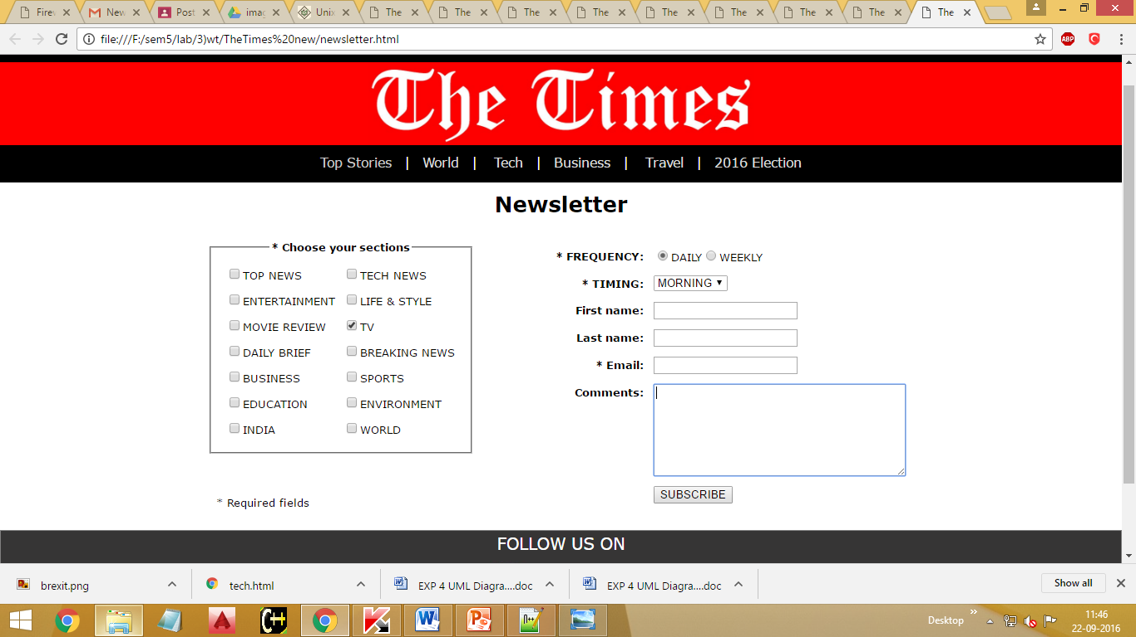

MAIN PAGE:

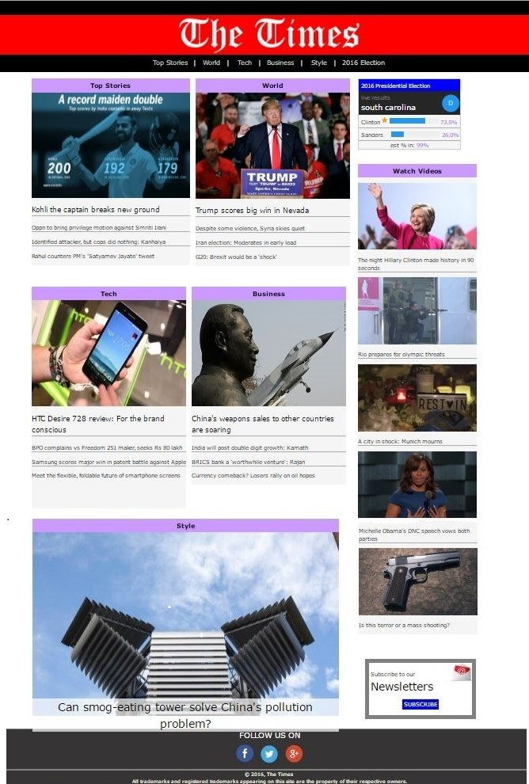

LOGIN PAGE:

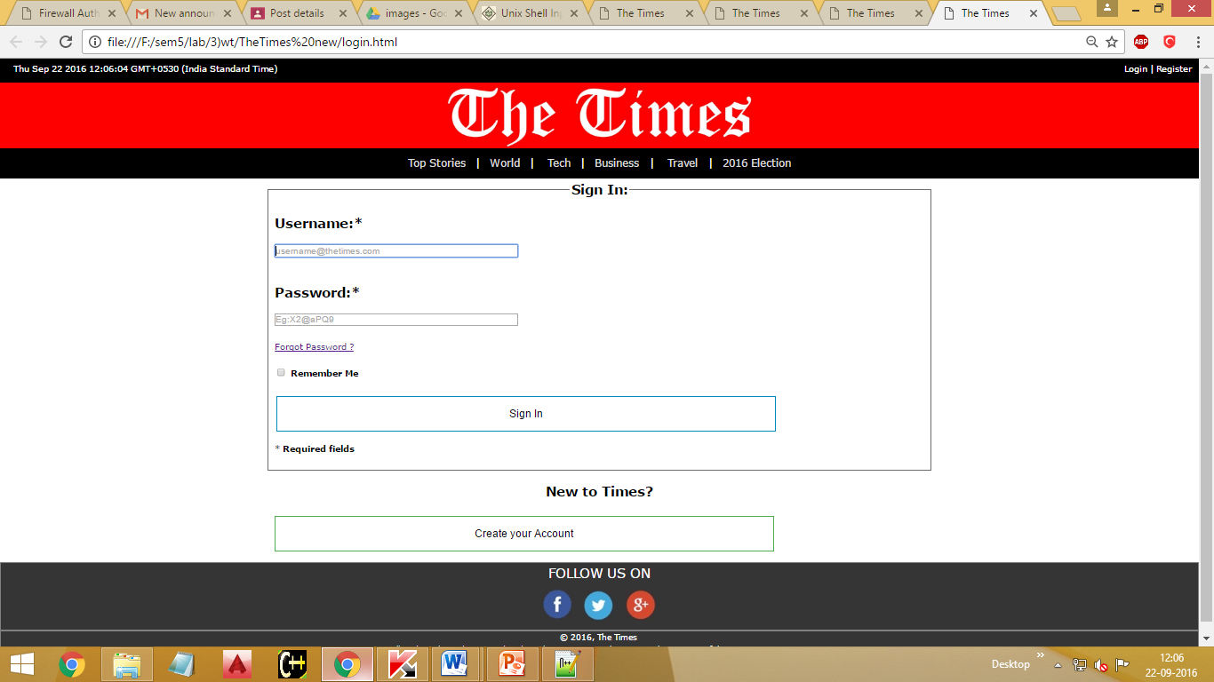

REGISTER PAGE:

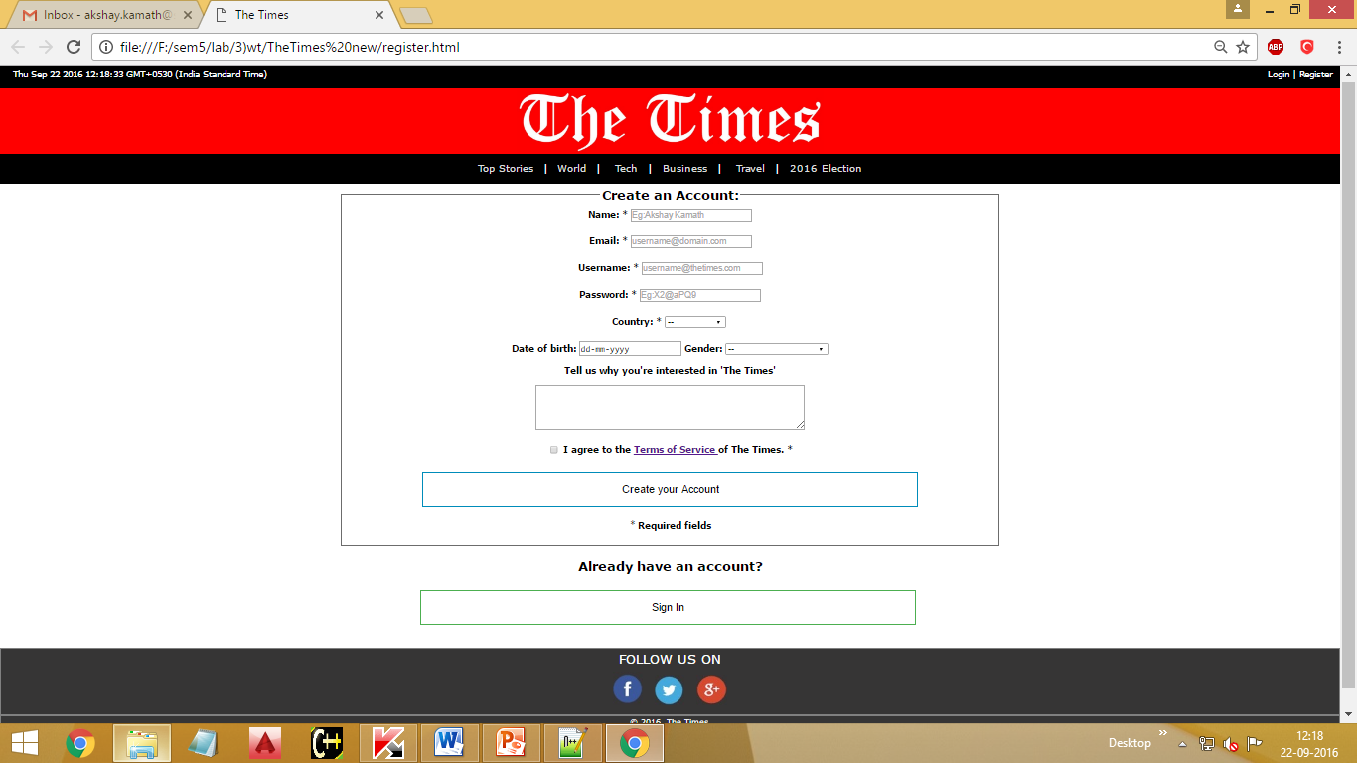

ARTICLE (POLITICS):

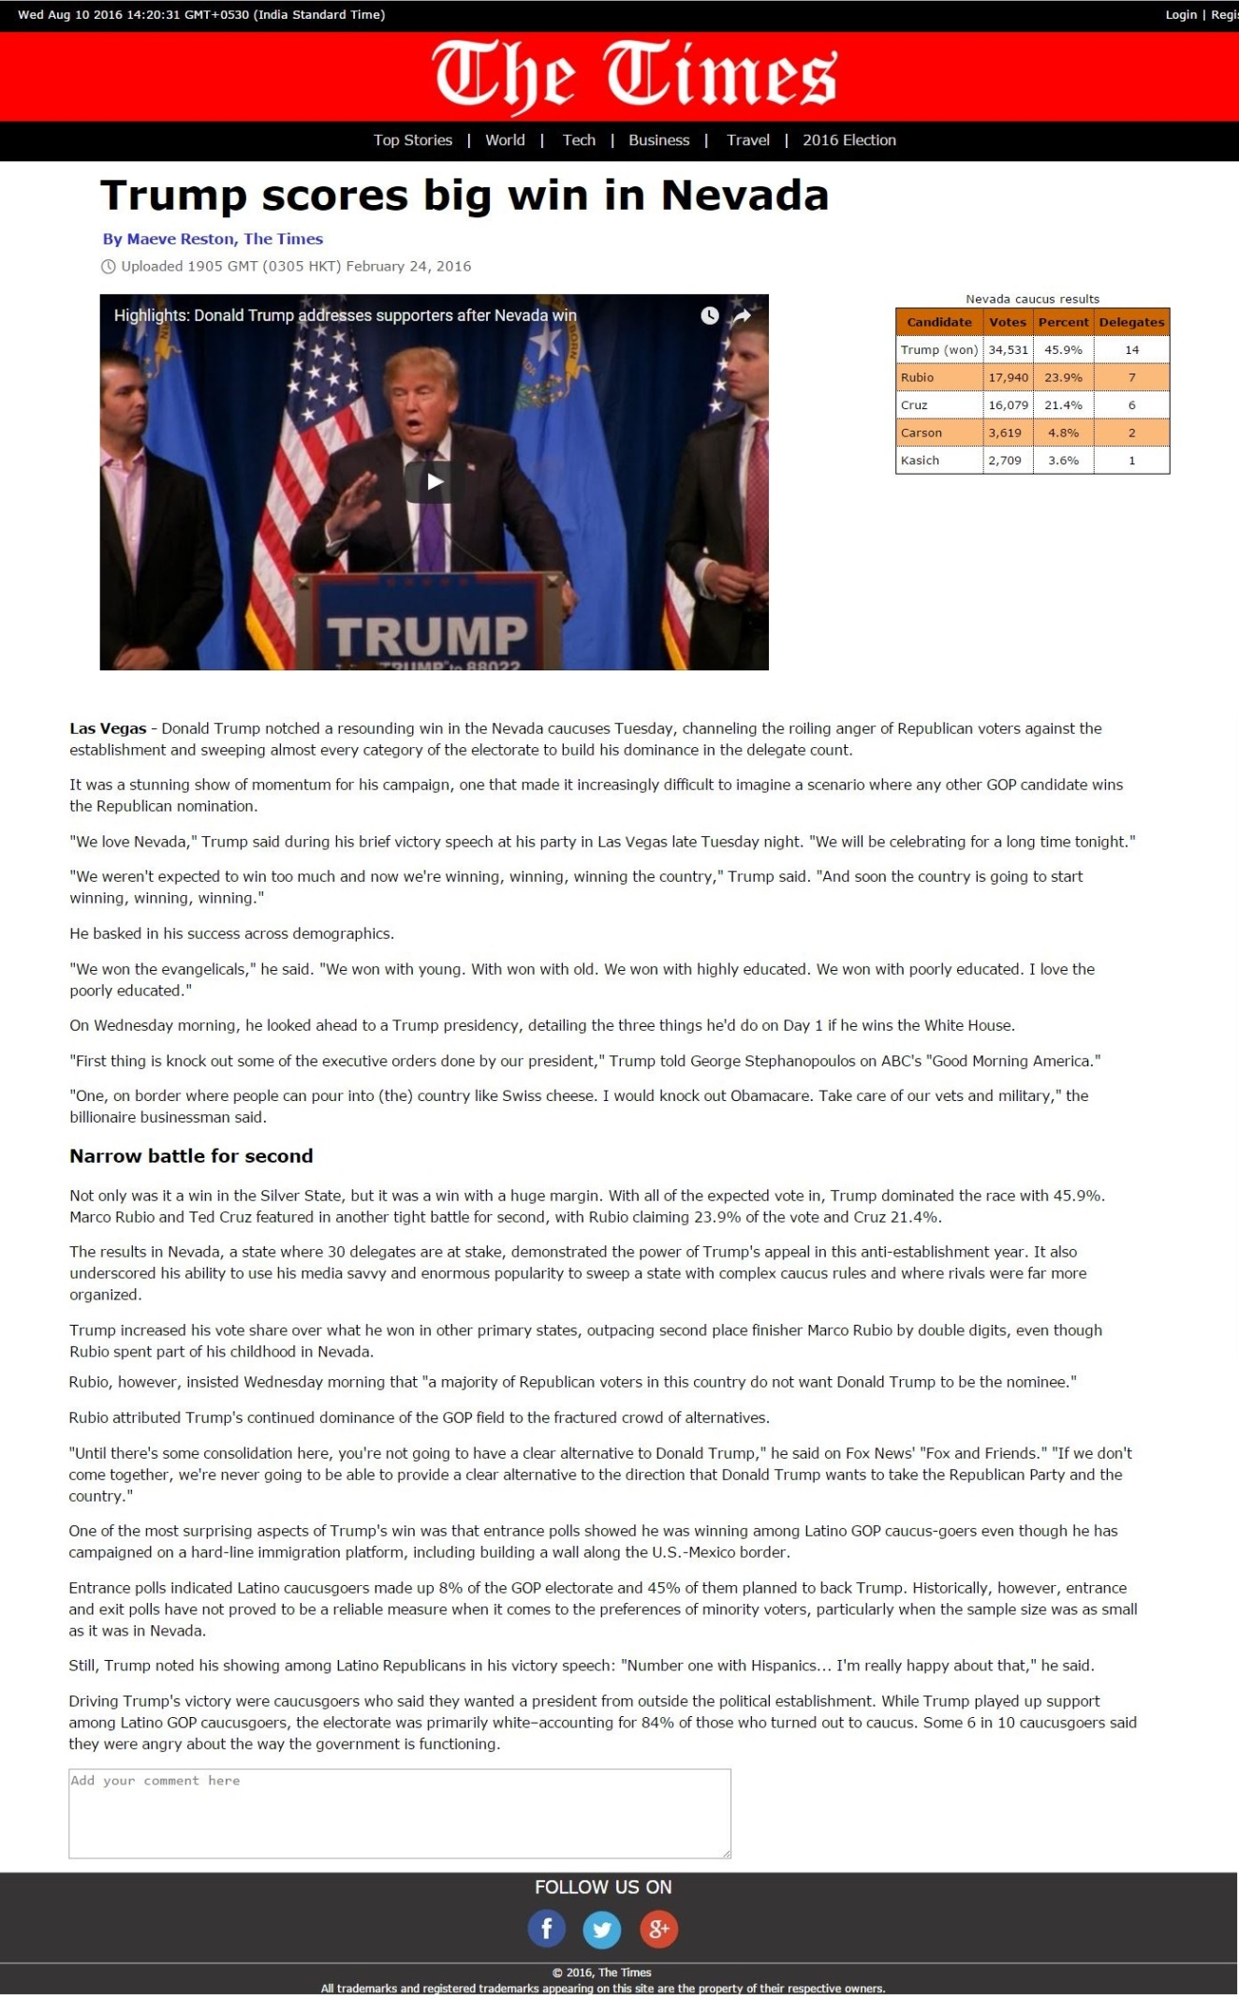ARTICLE (SPORTS):





ARTICLE(WORLD):



ARTICLE(BUSINESS):

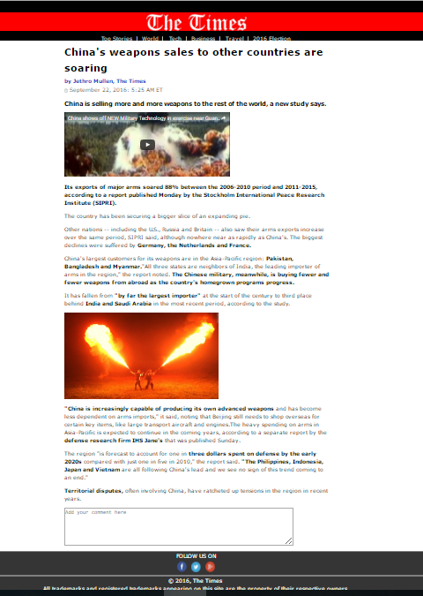

ARTICLE(STYLE):

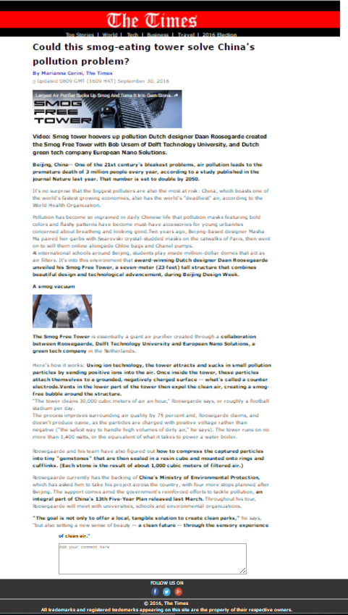

ARTICLE(TECHNOLOGY):

